**GMS Troubleshooting:**

I can’t enter….

It won’t let me…

All my boxes are gray……!!

**The 3 Most Common** **Issues**



***I Can’t Sign In to GMS***

1. Have I been added to the System? (See Figures #1, #2)
   * Ask your office who the User Access Administrator (UAA) is – This person can add you to GMS
   * Anyone with GMS access can look up the UAA - open Address Book from the static menu bars on the left, and select View All Grantee Contacts at the top of the Address Book page to see the Roles for each person
2. If I’m in the system, do I need to update my password?
   * See your local UAA who can reset your password
   * If you have not received a reset email – Check Your Junkmail!
3. Do I have the correct Roles?
   * See your local UAA who can add Roles to your sign on, allowing you to do more in GMS
4. I am the local UAA – Call DEED who will check steps 1-3 for you

***I Can’t Enter Any Information in GMS***

1. What is the STATUS of the grant? (See Figure #3)
   * Go to the Sections Page
   * At the Top, the STATUS must be Draft Started, Revision Started, or DEED Returned Not Approved. Another status means the grant is under DEED’s control
2. Do I have the correct Roles? Check with your local UAA – (see: “I can’t sign in” - #3)
3. I am the UAA – Check #1, and #2

***I Can’t Change the Status of My Application***

1. Are there any un-resolved ERRORS? (See Figure #3)
   * Go to the Sections Page
   * On the right hand side, in the Validation column, review all underlined Messages and look for any red ERROR messages. These must be corrected before a grant’s status can be changed
2. Do I have the correct Role to advance this grant? Check with your local UAA – (see: “I can’t sign in to GMS”)
3. I am the UAA – Check #1 and #2

Figure #2

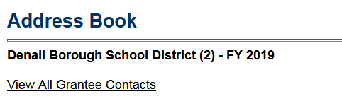Figure #1

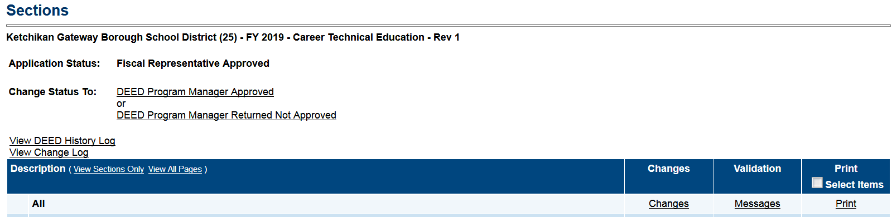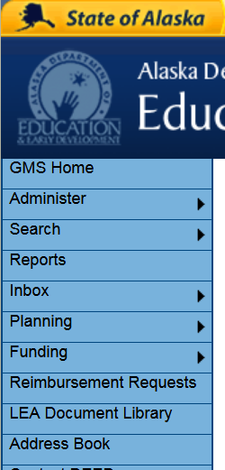

Figure #3